**DAILY ONLINE ACTIVITIES SUMMARY**

|  |  |  |  |  |  |  |  |
| --- | --- | --- | --- | --- | --- | --- | --- |
| **Date:** | **21/05/2020** | | | | **Name:** | **Ravi K R** | |
| **Sem & Sec** | **8th- B** | | | | **USN:** | **4AL16CS076** | |
| **Online Test Summary** | | | | | | | |
| **Subject** | | **SMS** | | | | | |
| **Max. Marks** | | **60** | | **Score** | | **45** | |
| **Certification Course Summary** | | | | | | | |
| **Course** | **Spring Framework Getting Started And Dependency Injection Fundamentals Tutorial For Real World Application Development** | | | | | | |
| **platform** | | | **udemy** | **Duration** | | | **2 hrs** |
| **Coding Challenges** | | | | | | | |
| **Problem Statement:**  **Collections in Java using collection framework like Array, vector, hash table** | | | | | | | |
| **Status: Executed** | | | | | | | |
| **Uploaded the report in Github** | | | | **Yes** | | | |
| **If yes Repository name** | | | | <https://github.com/Ravikr973161/certification-Programming> | | | |
| **Uploaded the report in slack** | | | | **Yes** | | | |

Online Test Details:

Certification:

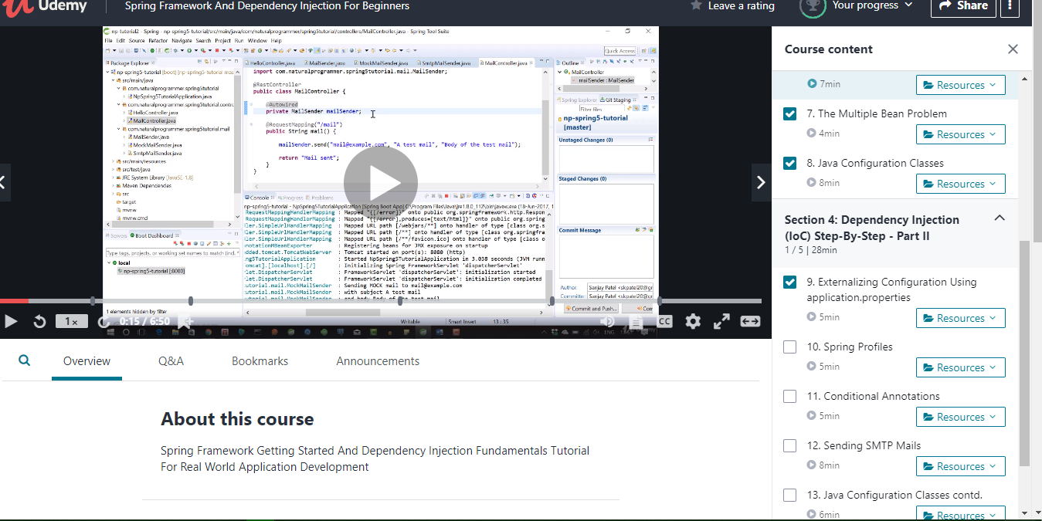

Coding Challenges Details:

import java.io.*;

import java.util.*;

class Test

{

    public static void main (String[] args)

    {

        // Creating instances of array, vector and hashtable

        int arr[] = new int[] {1, 2, 3, 4};

        Vector<Integer> v = new Vector();

        Hashtable<Integer, String> h = new Hashtable();

        v.addElement(1);

        v.addElement(2);

        h.put(1,"Hello");

        h.put(2,"world");

        // Array instance creation requires [], while Vector

        // and hastable require ()

        // Vector element insertion requires addElement(), but

        // hashtable element insertion requires put()

        // Accessing first element of array, vector and hashtable

        System.out.println(arr[0]);

        System.out.println(v.elementAt(0));

        System.out.println(h.get(1));

        // Array elements are accessed using [], vector elements

        // using elementAt() and hashtable elements using get()

    }

}